**DOCKER TASK 1**

Install docker on ec2.

Yum -y install docker

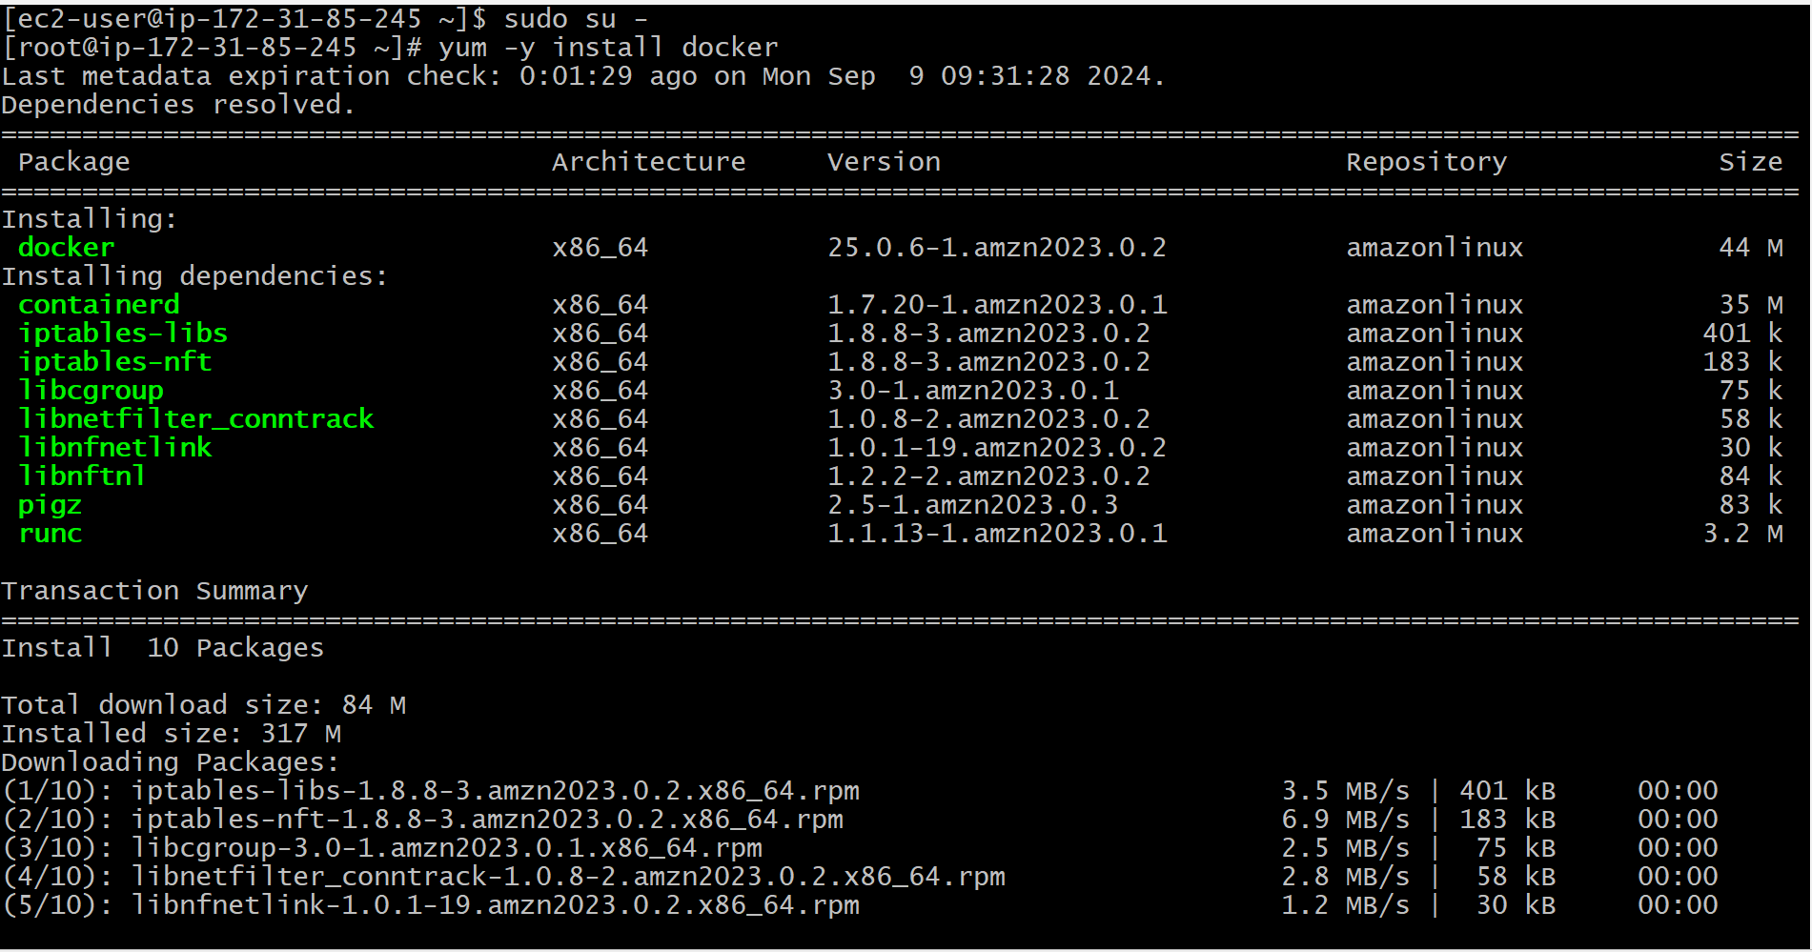

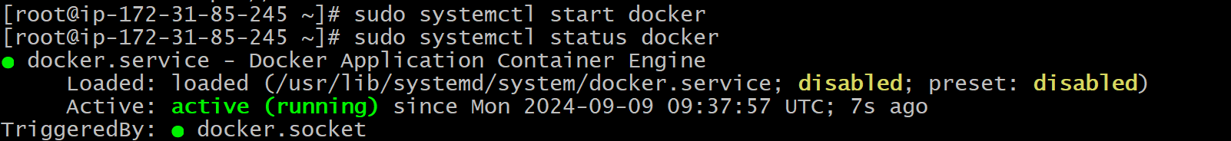

Pull 5 docker images. (Nginx, Apache tomcat, ubuntu, Jenkins, SonarQube)

Nginx

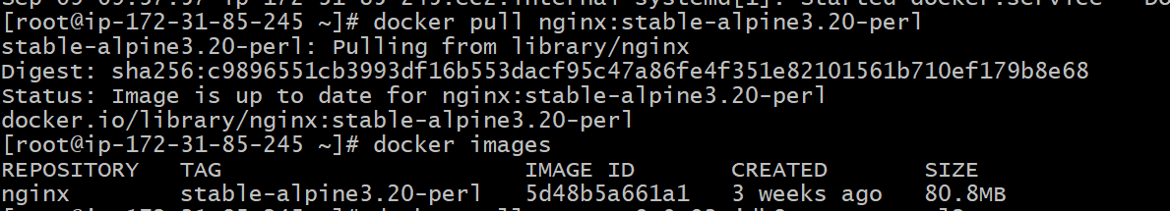

Apache tomcat

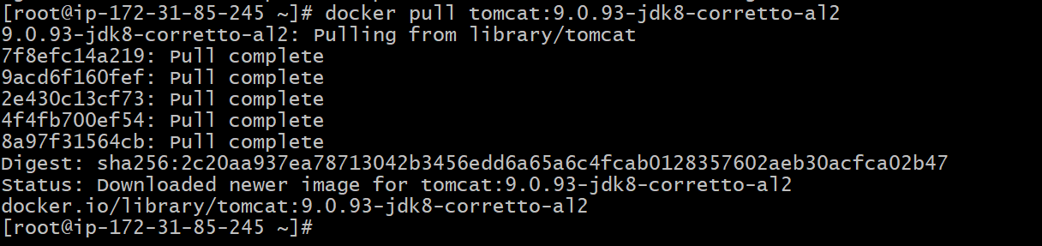

Ubuntu

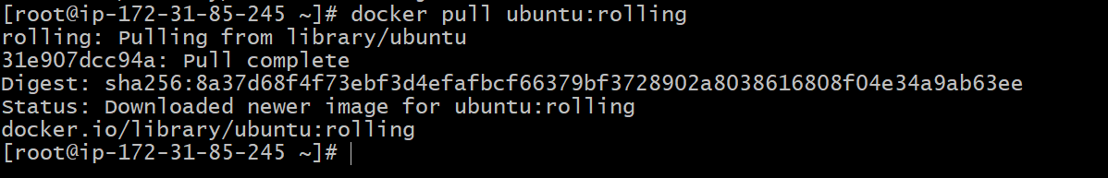

Jenkins

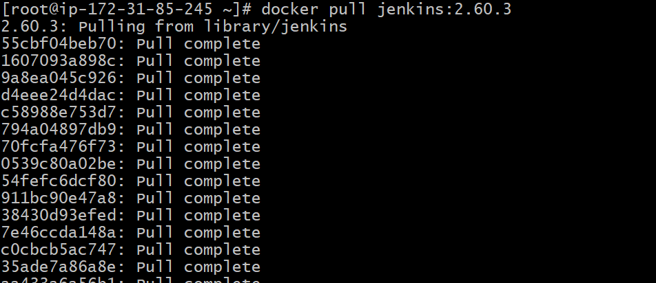

SonarQube

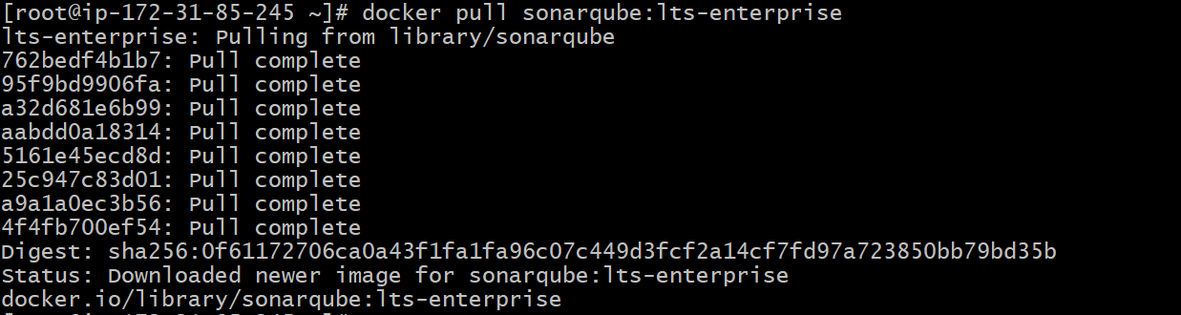

docker images --- this command is used to check all the images present in the docker

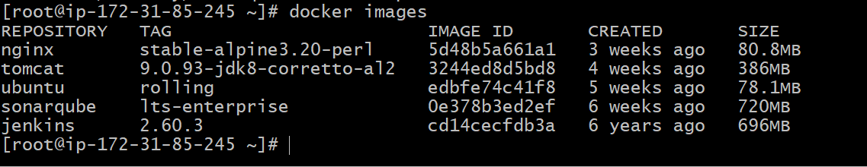

Run nginx container and expose on port 81.

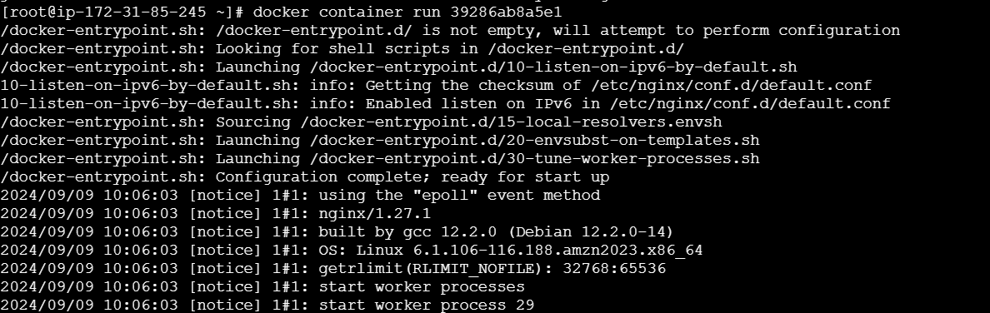

Run nginx container and expose on port 81.

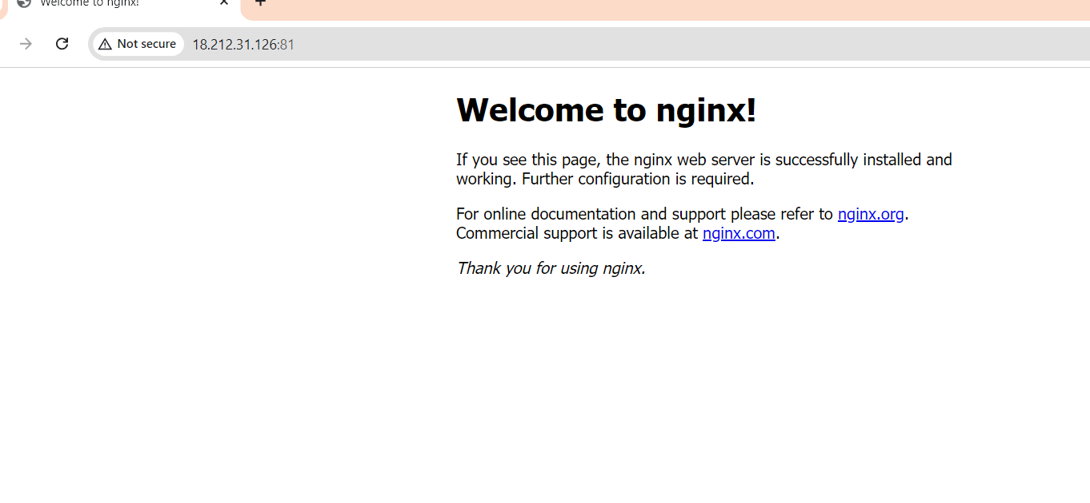

Delete the Apache tomcat image from local.

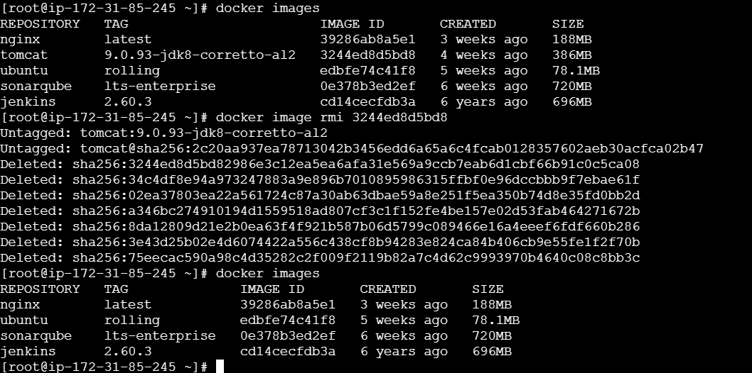

Inspect Jenkins image & SonarQube image

docker inspect Jenkins

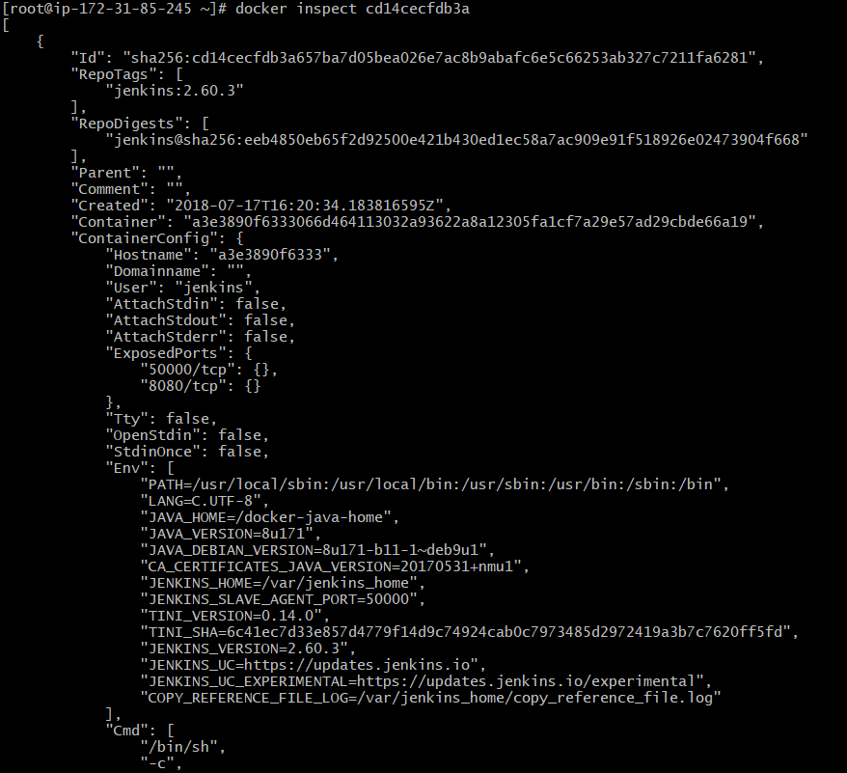

docker inspect SonarQube

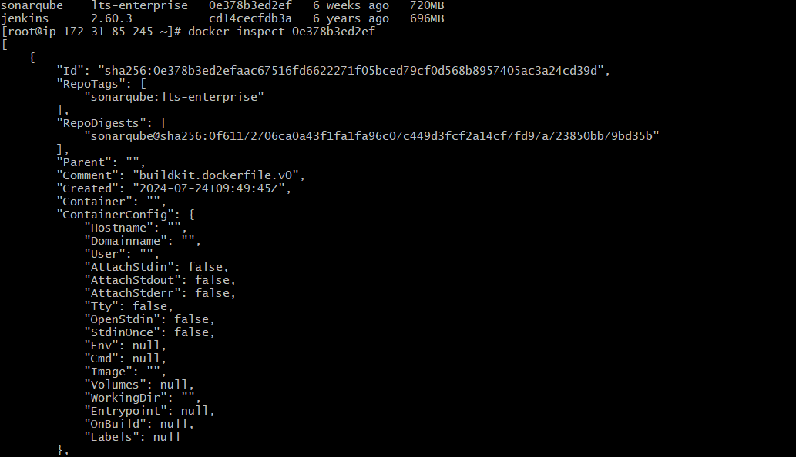

Run Jenkins container and run one sample job.



